SB 50 New Amendments - DRAFT
January 15, 2020

The office of Senator Scott Wiener released an update to SB 50 on January 6th ahead of its return to the California Senate floor on January 31st. In addition to rewrites for clarity and a revision to some definitions, four new amendments were added – a 2-year delay from what was originally proposed, increased local flexibility, designating the Governor’s Office of Planning and Research to develop local flexibility guidelines, and community preference. The bill is expected to continue to change.

- Implementation Delay
SB 50 would not go into effect until January 1, 2023. Jurisdictions would be allowed to delay implementation of SB 50 in potentially sensitive communities until July 1, 2023 and in determined sensitive communities until January 1, 2026.

How are Sensitive Communities defined?
- Sensitive Communities are defined as urban census tracts at the intersection of Metropolitan Transportation Commission’s Communities of Concerns and San Francisco Bay Conservation and Development Commission’s Disadvantaged Communities. While there is a separate, slower, timeline for implementation in sensitive communities, few parts of San Mateo County will qualify. The sensitive communities are mapped below.

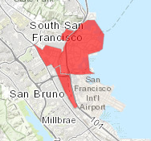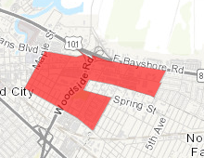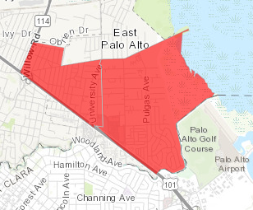

- The legislation mentions identifying additional Potentially Sensitive Communities, like inland areas, areas experiencing rapid housing cost changes or other areas based on objective measures.

- Potentially Sensitive Communities meet any of the following rules:
  - Designated as “high segregation and poverty” or “low resource” in the 2019 Opportunity Maps (California Tax Credit Allocation Committee)
  - A census tract that scores in the top 25 percent with the CalEnviroScreen 3.0 web-based tool or were identified by HUD in 2019

  - A qualified census tract identified by the United States Department of Housing and Urban Development for 2019

- Local Flexibility Plans
As of the January 6, 2020 revisions, jurisdictions are now allowed to create their own plan for increasing development near jobs and transit, referred to as a Local Flexibility Plan. Density must meet or exceed SB 50 in a way that reduces driving and affirmatively furthers fair housing, but cities and counties could use their discretion about the specific changes to make. For example, a city could allow up to six-story buildings on streets facing BART or Caltrain stations and step down to four-story buildings a block away, instead of allowing five-story heights for all buildings within a quarter mile, which the previous version of the bill required. Additionally, cities could exempt some neighborhoods entirely. Plan applications will be accepted beginning July 2021. Jurisdictions that do not complete a local flexibility plan by the July 2023 deadline will default to SB 50.

- Developing Guidelines for Local Flexibility Plans
The Governor’s Office of Planning and Research (OPR) is charged with developing the guidelines for local flexibility plans in the latest version of SB 50. In consultation with the Department of Housing and Community Development (HCD), OPR will design all requirements for local flexibility plans, applications and approvals, and make rules available on its website on or before July 1, 2021.

- Community Preference
Low-income residents living within one-half mile of a development at time of application are now given priority for affordable units. Forty percent of all affordable units will be reserved for low-income households. The Senator is continuing discussions with groups representing the interests of low-income communities, and this section is expected to further develop.

