Status Report on the San Mateo County Affordable Housing Multicity Nexus Study
Prepared April 2015

Executive Summary
In February 2014, fifteen jurisdictions in San Mateo County, plus Palo Alto hired Strategic Economics and Vernazza Wolfe Associates to produce nexus and feasibility studies that would allow cities to charge impacts fees for new residential or commercial development to fund affordable housing. The project was initiated and continues to be coordinated by 21 Elements, a countywide collaboration between all the cities in San Mateo County on housing issues.
Timing and Deliverable: In June 2015, participating cities will receive an affordable housing nexus and feasibility study for residential and/or commercial development, tailored to conditions in that jurisdiction.
Nexus Study – This report will document the relationship between new development and the need for more affordable housing. It will quantify the maximum legal fees that can be charged.
Feasibility Study – This report will makes recommendations about appropriate fee levels based on local conditions (e.g. current fees, market strength, etc.) These goal will be not to adversely impact potential new development.

For the past year, the consultant team has collected and analyzed data. Specifically, they documented how new development creates the need for additional affordable housing. The consultant team also analyzed market conditions, existing fees and other factors in each participating city so they can develop jurisdiction specific recommendations.
In April 2015, the consultant team will release a model report, based on Foster City data. All the reports will have a similar format and structure to the initial report, but with jurisdiction specific data. All the participating jurisdictions will receive their reports in June 2015. In addition, the consultant team will prepare a report summarizing trends and key findings throughout the county.
Once these reports are available, the jurisdictions will be able to consider appropriate follow-up actions. Possible actions include:
- Charging a fee on new residential development to fund the construction of new affordable housing.
- Charging a fee on commercial development to fund the construction of new affordable housing.
- Adjusting the jurisdiction’s inclusionary ordinance, if there is one, to be compliant with recent court decisions.
In addition, some jurisdictions may want to charge the fee only on rental development and apply inclusionary zoning requirements to condominiums. It is also an option to charge a fee to both commercial and residential development.
The hope is that having a multiple jurisdictions working collaboratively will result in better local solutions.
Timeline
Implementation - Timing Based on Individual City Needs
June – City Specific Reports
April 15 – Model Report

April 30 – Stakeholder Meeting
June/July - Countywide Summary Report

Policy Background
Several factors have increased the need for new policies to address affordable housing, including:
- Housing prices have increased rapidly. With the median sales price approaching $1 million, homes are unaffordable to most of the county’s workforce.
- Redevelopment Agencies, formerly the largest source of funding for affordable housing in California, were eliminated in 2012. Consequently, there is a need for new resources to assist in affordable housing development.
- Recent court cases have limited the ability of cities to implement inclusionary zoning. While inclusionary zoning is still legal in California, rental requirements have to be carefully structured to be compliant with recent court cases. Further, a case that is currently before the California Supreme Court has added additional legal uncertainty about inclusionary zoning. This case, CBIA v. City of San Jose, will be decided this summer.
Nexus and Feasibility Studies
Generally, affordable housing impact fees require new construction to pay money into a fund that is then used to support affordable housing development. To enact an affordable housing impact fee, cities must first conduct a nexus study that documents the relationship between the creation of new housing or jobs and the need for affordable housing in the community.
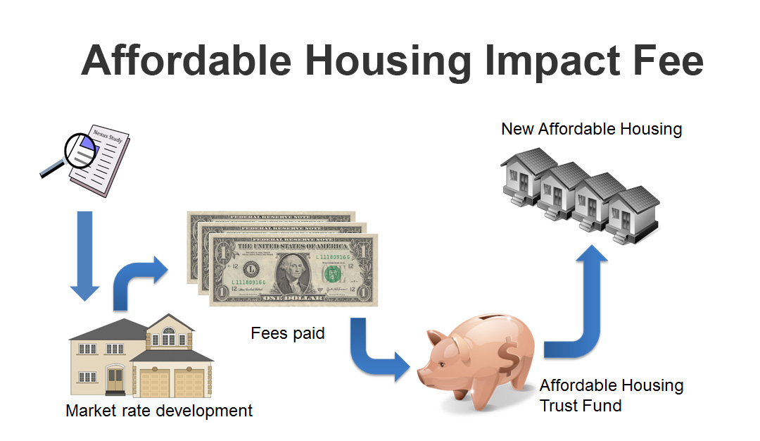
Basically, new residential development results in new jobs to service the new homes and residents. Landscapers, childcare workers and food service worker jobs will be created as a result of new development. Because many of these jobs pay low income wages, there will be a resulting demand for new affordable housing. The private sector is not supplying this product, so consequently the government has a role and interest in meeting this need.
The relationship between new homes, the jobs created and the need for affordable housing is summarized in the graphic below.
Residential Nexus
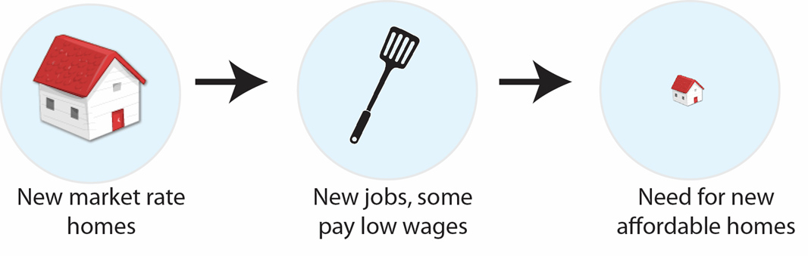

The relationship between commercial development and the need for new affordable housing is similar, but one step shorter since some of the jobs created by new commercial development will pay low income wages and thus create a direct demand for new affordable housing. This is shown in the graphic below.

Commercial Nexus
The nexus study examines these relationships in much greater detail. It looks at the income of new residents and their spending patterns, the growth in low income households associated with the new jobs, and the affordability gap, or difference, between what low income households can spend on housing and what new housing costs.
Multicity Nexus Study Process
Participating Jurisdictions
- Belmont
- Brisbane
- Burlingame
- Colma
- Foster City
- Half Moon Bay
- Menlo Park
- Millbrae
- Redwood City
- Pacifica
- Portola Valley
- San Bruno
- San Mateo County
- San Mateo (City)
- South San Francisco
- Palo Alto

San Mateo County has benefited from 21 Elements, an award winning collaborative project that brings together all the cities in the county to discuss housing policy. The project has made it easier and much less costly for jurisdictions to develop high quality, certified housing elements. 21 Elements has also coordinated the implementation of key housing policy projects for interested jurisdictions. Funding for 21 Elements is provided by the San Mateo County Department of Housing, the City/County Association of Governments of San Mateo County (C/CAG) and all the jurisdictions.
In 2013, San Mateo County cities began discussions about how to respond in a coordinated manner to the Palmer lawsuit that restricted rental inclusionary zoning. As a result, the cities decided to hire a consultant team to produce nexus and feasibility studies for all interested jurisdictions. Fifteen San Mateo jurisdictions and Palo Alto decided to join in this effort, which is a significant accomplishment because it represents every eligible jurisdiction, not counting those that already conducted nexus studies or those that were not expecting significant growth in the future (e.g. Atherton, Hillsborough, etc.). The cost for each jurisdiction is slightly over $15,000, which is about one-quarter of the amount it would have cost each jurisdiction to hire a consultant on its own. Enterprise Community Partners and the HUD Sustainable Communities Regional Planning Initiative provided grants to reduce the costs for cities. Foster City agreed to act as the financial sponsor, releasing the Request for Proposals (RFP) for consultant assistance and collecting and dispersing the funds to cover the costs of the studies.
In June 2015, all cities will receive their jurisdiction-specific residential and/or commercial nexus and feasibility studies. At this time, jurisdictions will have an opportunity to review their document and offer edits and other feedback. Once the reports are finalized, jurisdictions can decide on the next steps based on their individual needs and policy directions.

